European Hematology Association
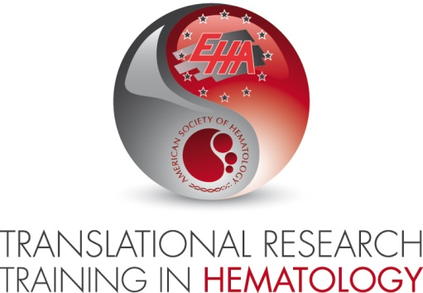
Attn: Deepa Maas
Koninginnegracht 12b
2514 AA The Hague
The Netherlands

Place, Date

Dear Reader,

This letter confirms that [APPLICANT FIRST NAME, LAST NAME] intends to submit an application for the 2018 Translational Research Training in Hematology.

The title of the proposed research project will be [PROJECT TITLE].
The project and application are supported by [MENTOR FULL NAME, MENTOR POSITION of MENTOR INSTITUTION].

Along with this Letter of Intent, you will receive a CV of the applicant (see next page) and a 350-word maximum abstract describing the proposed research project (references not necessary).

Please include all documents in one PDF file to be uploaded on the online system and name the submission file as follows: LastName_FirstName_Institute-LOITRTH2018.pdf

We herewith confirm to be aware of the terms and conditions related to participation in the TRTH Program:

- Applicant must attend TRTH meetings in whole at the following three events:
  - Spring Course: 9-16 March 2018, Italy (an in-house event, stay is required)
  - 23rd Congress of EHA, June 2018
  - 60th Annual congress of ASH, December 2018
- Applicant must respond to follow-up surveys in the future
- Applicant must accept responsibility for travel expenses which exceed the allowed amounts and/or travel arrangements which are outside of the established policies and procedures of TRTH
- Applicant must be the author of the research proposal. The mentor may offer limited help and is expected to be consulted on the choices made for scientific approach. However, the Joint Oversight Committee wishes to select applicants based on their own ideas, even if inspired by the mentor.

By signing this letter [APPLICANT FIRST NAME, LAST NAME] and [MENTOR FULL NAME] agree to comply with the terms and conditions for participation in the TRTH Program if the applicant is accepted.

APPLICANT | MENTOR
Signature | Signature
APPLICANT NAME | MENTOR NAME
Place, Date | Place, Date

Curriculum Vitae template

Name:
Date of birth:
Work Experience relevant to your research career:
Qualifications:

Publication list:

Abstract (max 350 words)

