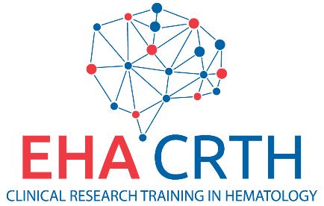
SIGNATURE LETTER FOR APPLICATION FOR CRTH

European Hematology Association
Attn: training@ehaweb.org
Koninginnegracht 12b
2514 AA The Hague
The Netherlands

[PLACE, DATE]

Dear Reader,

[APPLICANT FULL NAME] hereby submits an application for the 2021-2022 Clinical Research Training in Hematology Program.

The application is supported by [MANAGER FULL NAME, MANAGER POSITION of HOME INSTITUTION] in terms of allowing the applicant (in case of winning the award) to attend all three meetings.

We herewith confirm to be aware of the terms and conditions related to participation in the CRTH Program:

- Applicant must be available to attend CRTH meetings at the following three events:
  - 1st Workshop: Wednesday 13 October – Saturday 16 October 2021
  - 2nd Workshop: Wednesday 16 February - Saturday 19 February 2022
  - EHA Congress 2022: Thursday 9 June – Sunday 12 June 2022 (with the CRTH class meeting on Wednesday 8 June 2022)
- Applicant must respond to follow-up surveys in the future
- Applicant must accept responsibility for travel expenses which exceed the allowed amounts and/or travel arrangements which are outside of the established policies and procedures of CRTH
- Applicant must arrange valid travel documents and VISA

By signing this letter [APPLICANT FULL NAME] and [MANAGER FULL NAME] agree to comply with the terms and conditions for participation in the CRTH Program if the applicant is accepted.

[APPLICANT FULL NAME] [MANAGER FULL NAME]

Place, Date: Place, Date:

Signature: Signature:

