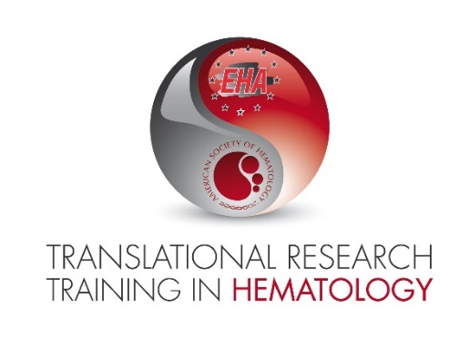
Please fill in all that is highlighted and add the relevant signatures. You may remove the highlights after filling out the form. Please save as a PDF file to be uploaded on the online system and name the submission file as follows:
LastName_FirstName_Institute-LOITRTH2022.pdf

Dear Co-Directors for TRTH,

This letter confirms that [APPLICANT FIRST NAME, LAST NAME] intends to submit an application for the 2022 Translational Research Training in Hematology.

The title of the proposed research project will be [PROJECT TITLE].
The project and application are supported by [MENTOR FULL NAME, MENTOR POSITION at MENTOR INSTITUTION].

We hereby confirm to be aware of the following terms and conditions related to participation in the TRTH Program:

- Applicant must attend TRTH meetings in whole at the following three events:
  - Spring Course: 11-18 March 2022, Paris, France (an in-house event for 8 days, stay is required)
  - Congress of EHA 2022, June 2022
  - 64th Annual Meeting of ASH, December 2022
- Applicant must participate in pre-course, during course and follow-up surveys in the future
- Applicant must accept responsibility for travel expenses which exceed the allowed amounts and/or travel arrangements which are outside of the established policies and procedures of TRTH
- Applicant must be the author of the research proposal. The mentor may offer limited help and is expected to be consulted on the choices made for scientific approach. However, the Joint Oversight Committee wishes to select applicants based on their own ideas, even if inspired by the mentor.

By signing this letter [APPLICANT FIRST NAME, LAST NAME] and [MENTOR FULL NAME] agree to comply with the terms and conditions for participation in the TRTH Program if the applicant is accepted.

APPLICANT | MENTOR
Sign here: | Sign here:
APPLICANT NAME | MENTOR NAME
Place, Date | Place, Date

